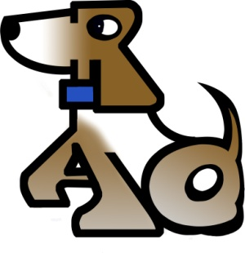 Rescue A Dog, Inc.
Owner Surrender Form
Owner’s Information:
Name:
Street Address: City: State:
Zip Code: Phone: ( ) Date of Birth:
Email:

Dog’s Information:
Name: Breed: Sex: M F
Age: Spayed Neutered Not Altered
Why are you surrendering this dog?
Where did you get this dog?
Is this dog micro chipped? Yes No

Policy Statement
I , being owner of , being a
(owner) (name of dog)

(description of dog, color, age, weight, etc.)
hereby voluntarily relinquish all claims and ownership of said dog to the organization known as Rescue A Dog (RAD) and members thereof. I cannot reclaim this dog once the dog is in possession of RAD and understand that this animal will be spayed or neutered, if needed. I agree to give up the dog’s AKC registration papers and all medical records available. Neither RAD nor members thereof shall be held responsible for actions of the adoptive or foster family and/or dog. I certify that this dog is not vicious and has never shown signs of aggression towards human beings.
Signature: Date:
Printed Name:
State Driver’s License #:

