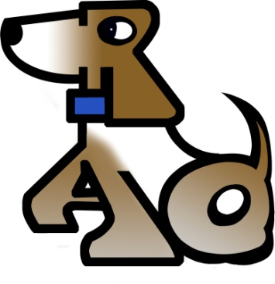 ADOPTION CONTRACT
Please initial the following:
I/We have never been charged nor investigated for animal cruelty and agree to a full background check.
I/We am/are adopting (ID: )
I/We agree that the dog will not be off lead except when inside the house or within the safety of a fenced backyard.
I/We agree that the dog will not be abused in any manner. The dog will not be chained, roped or otherwise tethered outside at any time. I/We agree that the dog will not be left outside unattended at any time. The dog will not be trained or used for attack of guarding property and will never be used in any aspect of dog/animal fighting or other illegal practices. The dog will not be the subject of, nor subjected to any biological, chemical, psychological or other experiments, nor shall the pet be subjected to shock collars or other cruel means of training.
I/We agree that the dog will not be subjected to any form of cosmetic surgery or altercation.
I/We understand and agree that Rescue A Dog, Inc. makes no express or implied warranty, representation or promise to the age, health, breed, habits, disposition or safety of the animal. I/We hereby accept the animal as is, assume all risks and responsibilities associated with the ownership of the Animal, including bites, and I hereby fully and completely release, indemnify and hold harmless Rescue A Dog, Inc., its directors, officers, volunteers, servants, and employees from any claim, cause of action or liability of any sort or nature, whether known or unknown, directly or indirectly arising out of or in connection with the adoption, care or ownership, maintenance, temperament or condition of the Animal.
I/We agree in the case I cannot keep the animal, he/she will be returned to Rescue A Dog, Inc.
I/We agree to notify RAD with any changes of address, phone number, etc.
I/We agree to comply with all state and local laws and ordinances related to keeping of this dog, including licensing and leash laws.
I/We acknowledge falsification of the above can result in my being denied adoption of an animal or, if animal has been adopted to me, the return of that animal to Rescue A Dog, Inc.
I/We certify that the above information is true and correct to the best of my knowledge
This contract constitutes the full agreement and understanding of both parties.
Signature: Date:
Printed Name:
Representative Signature:

*All Monies received for animals will be considered donations to Rescue A Dog and are non-refundable.

